**E-COMMERCEPLATFORM**

1.Asymptotic Notation

a) Big O notation describes how an algorithm’s space grows with input size.

Example- O(n) means time is increasing linearly with input.

b) best case: fastest time an algorithm takes.

Average Case: expected runtime over all inputs.

Worst Case: It takes longest time (example: item not found or at the end.

EcommerceSearch.java

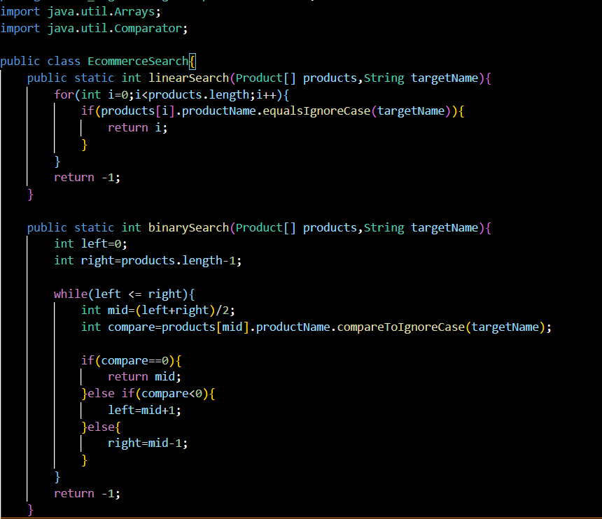

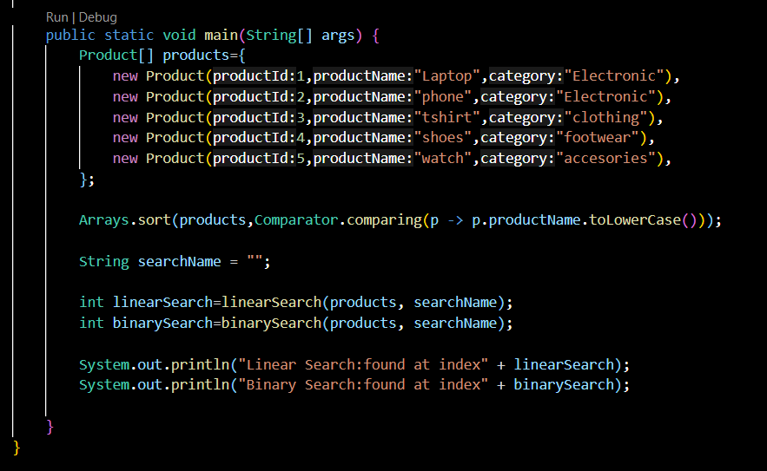

Product.java

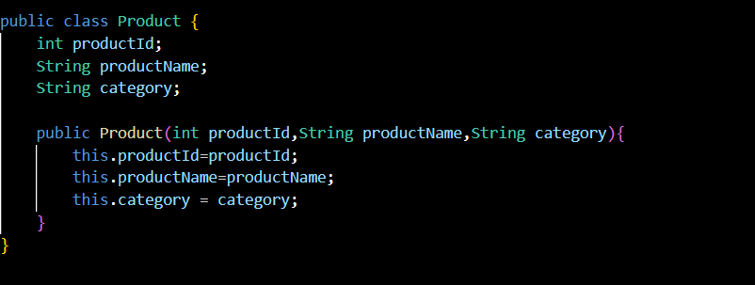

**OUTPUT**



4.Analysis

a) Linear Search

Time complexity :O(n), simple but slow for large data

b) Binary Search

Time complexity :O (log n), It is faster but works with sorted data.

CONCLUSION:

For E-commerce Platform, binary search is more suitable due to its faster performance on sorted data.